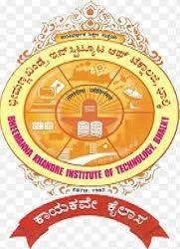
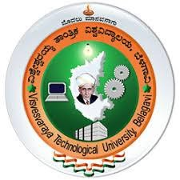
BHEEMANNA KHANDRE INSTITUTE OF TECHNOLOGY, BHALKI
“Java Full Stack With Gen AI”
Presented by:
Name: Ankita
USN:3RB22CS008

Introduction
- The internship at Dhee Coding Lab focuses on full stack development, covering
both frontend and backend basics.
- I learned technologies like JavaScript, Core Java, and SQL, along with
understanding how web applications are structured.
- The training helped me improve my fundamentals, coding skills, and problem-
solving ability.
- I also gained hands-on experience in implementing features and debugging.
- I learned how different parts of an application connect and work together in a real
environment.
- It also improved my ability to think logically and write cleaner code.
- Overall, it made me more confident in understanding and building web applications.

About Company

Dhee Coding Lab is a specialized training institute under Prodhee Technologies, focused on building strong software development skills through structured and practical learning. It provides training in full stack development and modern technologies, helping students understand how real-world applications are designed and developed. The institute emphasizes hands-on learning, guiding students from basic concepts to industry-level skills.
The organization is supported by experienced IT professionals and follows a practical approach similar to real software development environments, including requirement understanding, prototyping, and implementation. It also focuses on emerging technologies like AI, cloud computing, and data-driven systems, helping students gain relevant industry exposure and
prepare for careers in the tech field.

Weekly Report
Week 1: Introduction to Web Development, overview of Full Stack, basics of HTML
(structure, tags), and understanding front-end vs back-end
Week 2:HTML elements (images, links, tables), forms and inputs, basic CSS introduction (inline, internal, external), Java basics (what is Java, OOP concepts overview)
Week 3: CSS fundamentals (selectors, classes, IDs, box model), Java concepts (data types, variables, operators), introduction to development tools (JDK, Eclipse setup)
Week 4: Advanced CSS (positioning, layouts), JavaScript basics (console, variables, functions), Java concepts (control statements, loops)
Week 5:JavaScript arrays, objects, functions, string & number methods, Java OOP concepts (classes, objects, constructors, method overloading)
Week 6: JavaScript DOM basics, events, form handling, Java concepts (inheritance, method overriding, encapsulation, abstraction)
Week 7: JavaScript advanced concepts (loops, nested logic, problem-solving), Java exception handling (try-catch, throw, throws, finally), introduction to SQL
Week 8: SQL basics (DDL, DML, table creation), constraints (primary key, unique, not null), Java collections introduction (ArrayList, LinkedList)
Week 9: SQL queries (SELECT, WHERE, ORDER BY), joins (inner, left, right, self), Java collections (Set, Map, HashMap, Queue)
Week 10: SQL advanced concepts (subqueries, nested queries, functions), Java problem solving (sorting, searching, time complexity), introduction to algorithms
Week 11: Sorting algorithms (bubble sort, merge sort), pattern programming, SQL optimization concepts, Java advanced topics (wrapper classes, String, StringBuffer)
Week 12: Advanced Java introduction (J2EE overview), collections deep dive, HashMap usage, frequency problems, revision of core Java concepts

Workflow
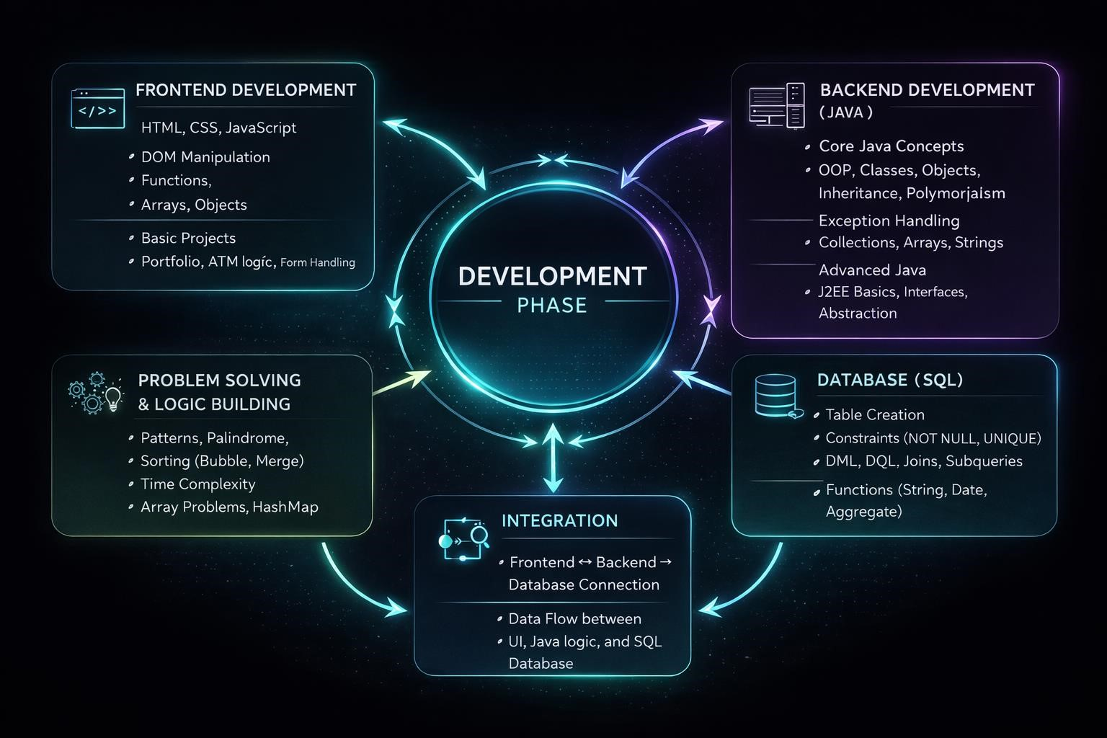

Conclusion
- Gained strong understanding of Front-end development using HTML, CSS, and JavaScript and especially Core Java.
- Developed the ability to build responsive and interactive web applications.
- Improved problem-solving skills and logical thinking through hands-on practice.
- Learned to follow proper coding standards and structured development approaches.
- Overall, the internship provides practical exposure and enhanced readiness for real-world software development

Thank You

